2023

Priya

IRCTC

9/8/2023

Irctc User Manual

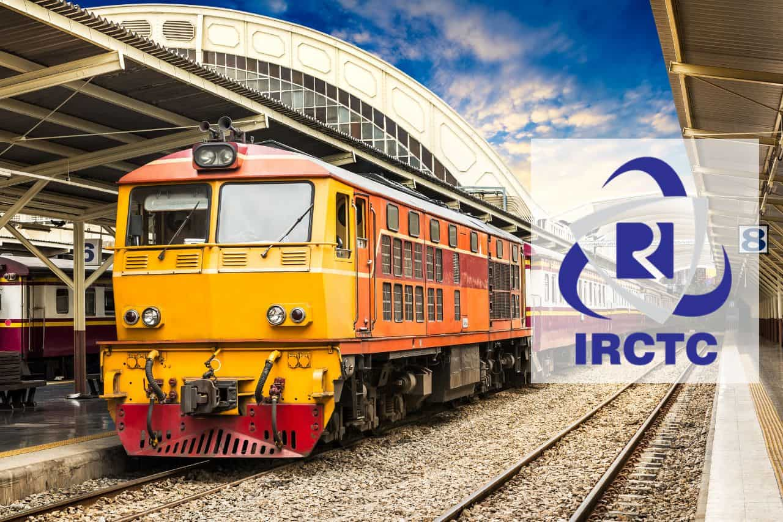

# Copyright

© 2023 IRCTC. All rights reserved.

All content, images, and logos are the property of IRCTCunless otherwise noted.

Trademark Information:

- The IRCTClogo is a registered trademark (®) of IRCTC.

- "Sites" are trademarks (™) of IRCTC.

Terms of Use:

1. You may view, download, and print this document for personal, non-commercial use only.

2. You may not reproduce, distribute, modify, or publicly display this document without prior written permission from Your Company Name.

3. Any unauthorized use may result in legal action.

# Document History

| Date | Author | Document Status |
| --- | --- | --- |
| 6th September | Priya | Started |
| 10th September | Priya | 1st draft |
| 11th September | Priya | Modifying draft |
|  |  |  |
|  |  |  |
|  |  |  |
|  |  |  |
|  |  |  |
|  |  |  |
|  |  |  |
|  |  |  |
|  |  |  |
|  |  |  |
|  |  |  |
|  |  |  |
|  |  |  |
|  |  |  |
|  |  |  |
|  |  |  |
|  |  |  |
|  |  |  |
|  |  |  |

# Preface

Welcome to the Indian Railway Catering and Tourism Corporation (IRCTC) User Manual! We are delighted to have you as a valued user of our services.

* About This Manual

This user manual has been crafted with the intention of providing you with comprehensive guidance on navigating and utilizing the various features and functions offered by IRCTC. Whether you are a seasoned traveler or a first-time user, we hope this manual will assist you in making your railway journeys more convenient and enjoyable.

* What You'll Find Inside

In the following pages, you will discover step-by-step instructions, tips, and insights on:

Booking Train Tickets: Learn how to book train tickets effortlessly using our online platform or mobile app.

Booking and Modifying Reservations: Discover the process of modifying your ticket bookings as per your requirements.

* Your Feedback Matters

At IRCTC, we are committed to providing you with the best possible user experience. Your feedback and suggestions are invaluable in helping us improve our services continually.Pleasedo not hesitate to reach out to our customer support team. Click [here](https://irctc.com/contact.html) to go to that site if you have any questions or if there is anything we can assist you with.

* Disclaimer

Please note that the information in this user manual is subject to change without notice. IRCTC reserves the right to modify its services and policies as necessary. For the most up-to-date information, visit our official website or contact our customer support team.

Thank you for choosing IRCTC. We wish you safe and pleasant travels!

# Table of Contents

Copyright 1

Document History 2

Preface 3

Table of Contents 5

Table of Figures 5

Chapter -1 6

Chapter 1.1-Introduction 6

Chapter 1.2 -Registration 8

Chapter 1.2 -LOGIN 12

Chapter 1.3- Log out 13

Chapter 1.4 - To Retrieve Password 13

Chapter -2 14

Chapter 2.1 -OnlineTicketReservation 14

Chapter 2.2 - Book a E-Ticket 15

Chapter 2.2.1- Enter journey details. 15

Chapter 2.2.2- Select train. 17

Chapter 2.2.3- Select Seat. 18

Chapter 2.2.4- Enter Passenger details. 19

Chapter 2.2.5-Check details. 21

Chapter 2.2.6- Payment. 22

Chapter 2.3 - BookaTatkalTicket 23

# Table of Figures

Figure 1 8

Figure 2 9

Figure 3 10

Figure 4 11

Figure 5 12

Figure 6 15

Figure 7 16

Figure 8 17

Figure 9 18

Figure 10 18

Figure 11 19

Figure 12 20

Figure 13 21

Figure 14 22

Figure 15 23

Figure 16 24

Figure 17 25

# Chapter -1

## Chapter 1.1-Introduction

The Indian Railway Catering and Tourism Corporation (IRCTC) is a division of the Indian Railways that manages the Indian Railways' online ticketing, tourism, and catering activities.

The IRCTC has an online reservation system that allows you to order tickets from the convenience of your own home or business. It has made life easier for folks who live in rural areas.

Train ticket reservations and cancellations can be done on the official website [www.irctc.co.in](http://www.irctc.co.in).

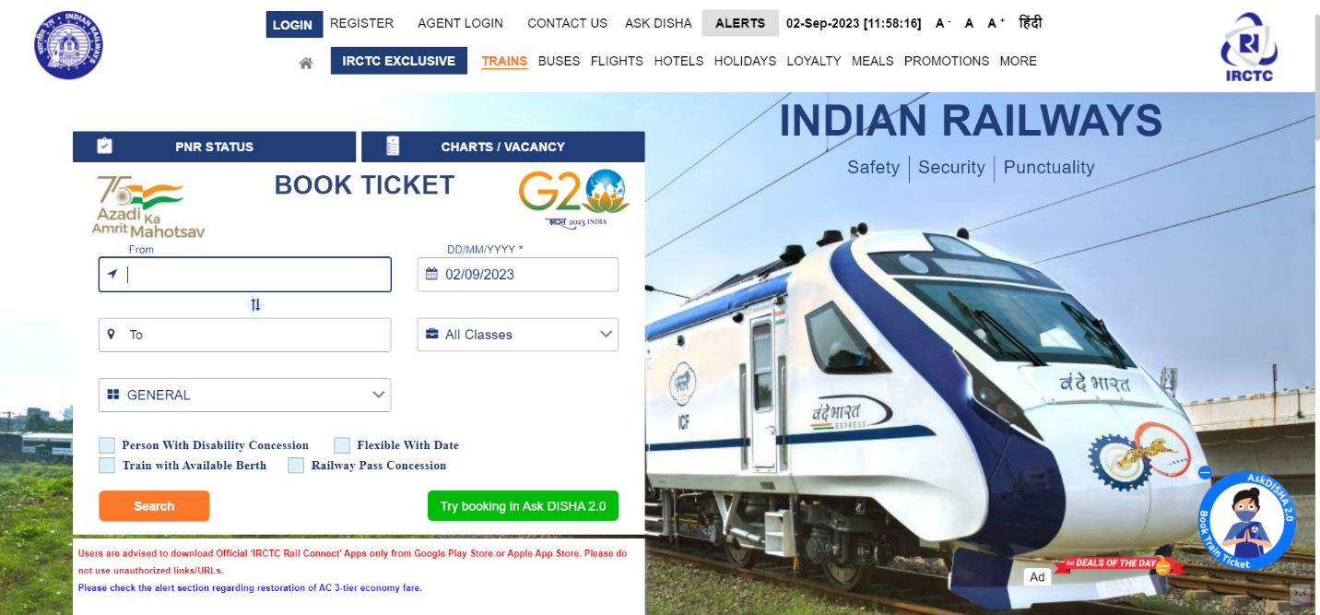

Figure 1

## Chapter 1.2 -Registration

Individual registration is completely free. Click REGISTER on the IRCTC home page.The following are the prerequisites for an Indian resident to register on the IRCTC website:

* A valid, active email Id.
* A working phone number.

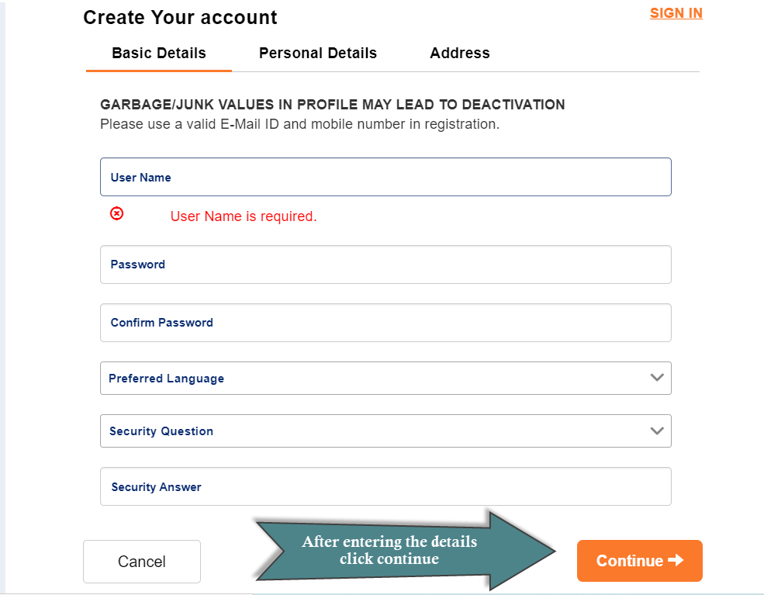

Figure 2

1. User name should be unique and between 3 to l0 characters. Password should be alphanumericalandbetween8tol5characters.
2. EnterPasswordofyourchoiceinthePasswordtextbox.
3. Re-enterthesamepasswordintheConfirmPasswordtextbox.
4. Select preferred language from the choice given.
5. SelectasecurityquestionofyourchoicefromtheSecurityQuestionlist.
6. Entertheanswerofyourchoiceinthesecurityanswertextbox.

(Note-Incaseyouforgetyourpassword,securityanswerhelpsyoutorecoveryouraccount.)

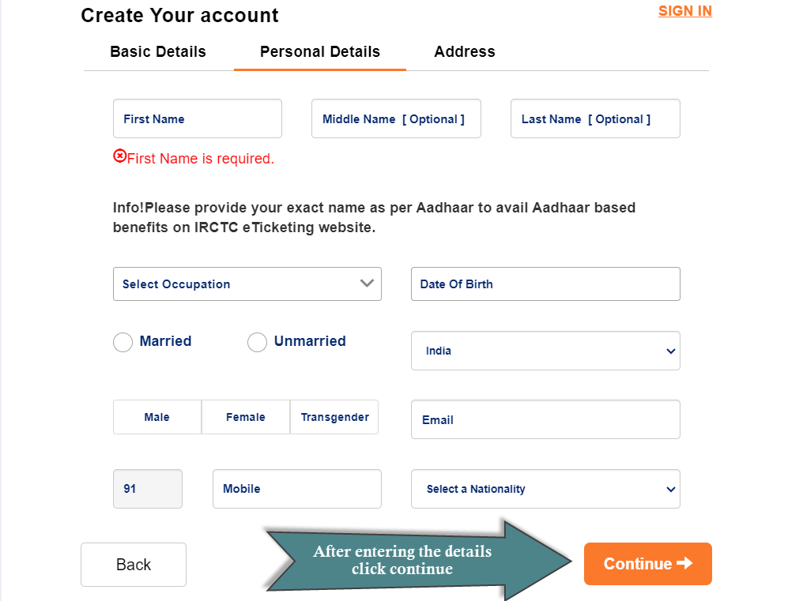

Figure 3

Enter your Name (First Name, Middle name, Last Name), Gender, Marital Status, Occupation, and Date of Birth, Valid Mobile number, Nationality, valid email id in the personal details section.

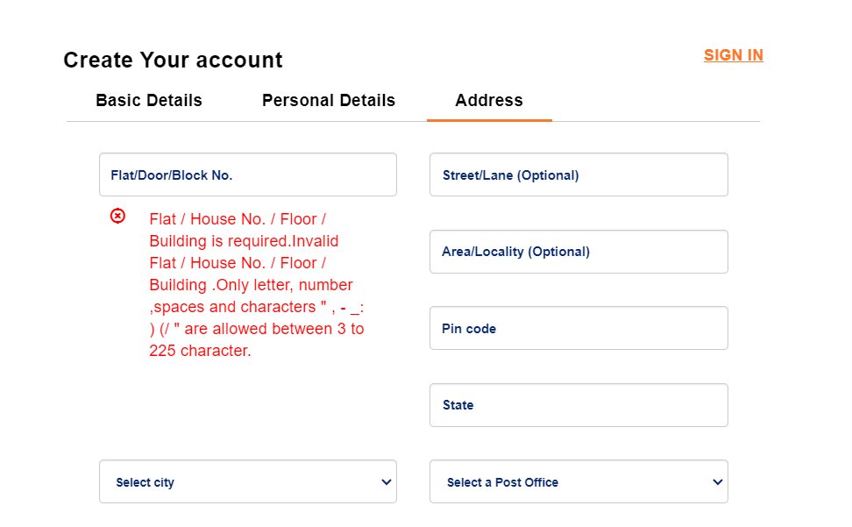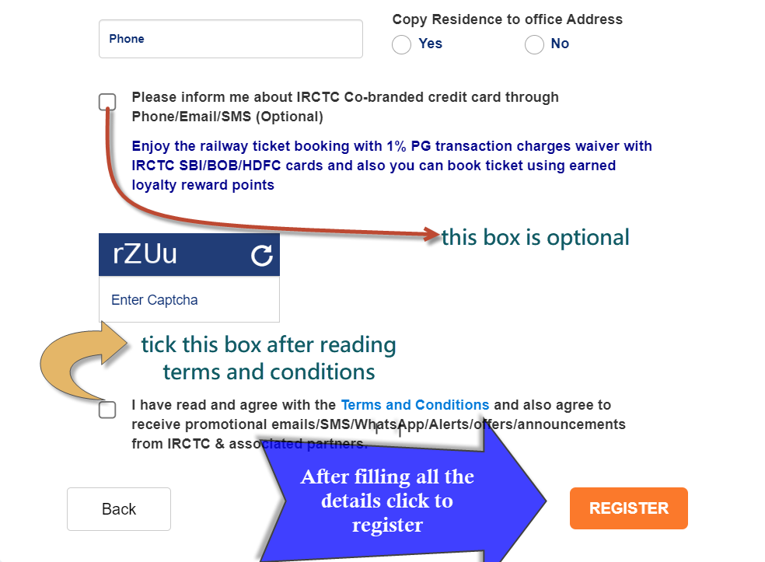

Figure 4

1. Enter all the address details asked you can skip optional once.
2. Enter the security characters as displayed in the box.
3. If you want to make any modifications to previous inputs, you can do that by clicking **Back**.
4. Click **Register** to complete registration.

## Chapter 1.2 -LOGIN

1. Open a browser and type [www.irctc.co.in](http://www.irctc.co.in/)in the address bar. The IRCTC login page
2. On the IRCTC home page, clickLOG IN. The Login dialog box appears as shown below.

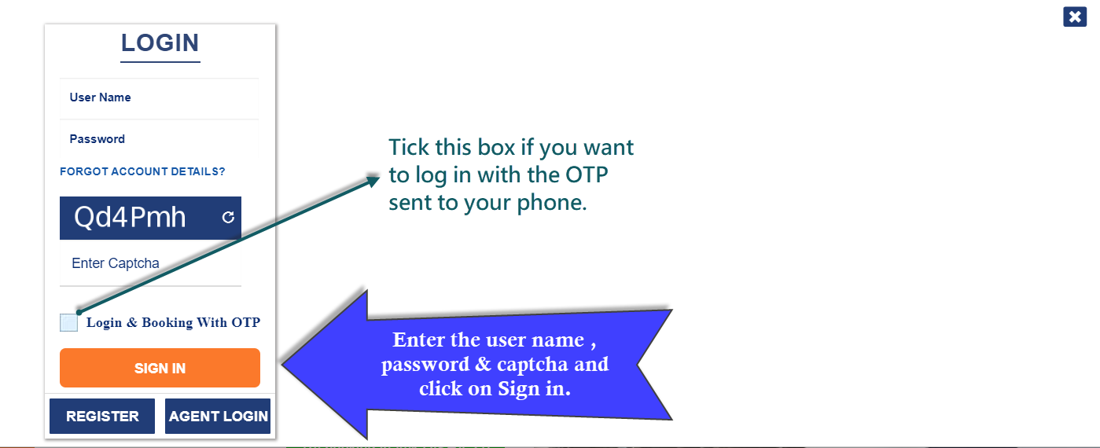

Figure 5

1.Enter yourusername.

2.Enteryour password.

## Chapter 1.3- Log out

On the IRCTC home page, click Logout.

## Chapter 1.4 - To Retrieve Password

1. ClickForgotAccount detailsontheLoginpage.
2. In theEmailtextbox,entertheregisteredemailaddress.Alinktoresetthepassword sent to this email address.

# Chapter -2

## Chapter 2.1 -OnlineTicketReservation

IRCTC allows customers to book Indian Railways train tickets between stations and among the trains available on the route. IRCTC allows consumers to book two types of train tickets.

Types of train tickets:

1. E-Ticket
2. Tatkal Ticket

Passengers who plan their journey on short notice can book tickets in practically all Mail/Express trains using the Indian Railways' internet portal under the Tatkal scheme.

Tatkal tickets can only be ordered one day before the journey date, at 10:00 a.m. (I.S.T) for A.C coaches and 11:00 a.m. (I.S.T) for Sleep Class (SL).

## Chapter 2.2 - Book a E-Ticket

### Chapter 2.2.1- Enter journey details.

1. OntheBook ticket page,provide your desired from-to station, date of journey.
2. Select a class of our choice or you can keep it as All Classes.
3. In case you do not have a fixed date for your journey, select the "Flexible with Date" option.
4. Select ticket type general /tatkal/ladies/premium tatkal/senior.

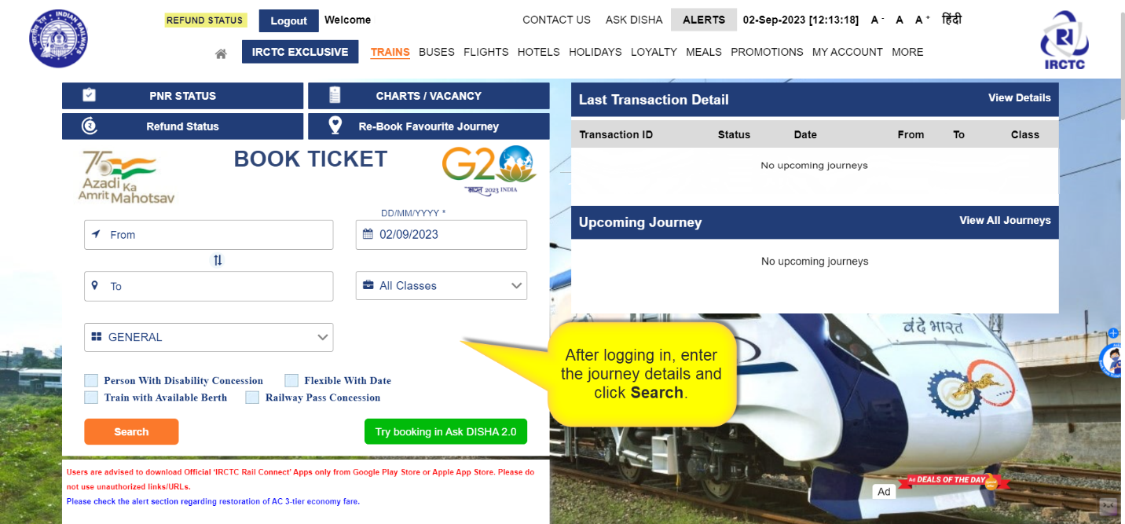

Figure 6

An example of a journey I have filled just for reference.

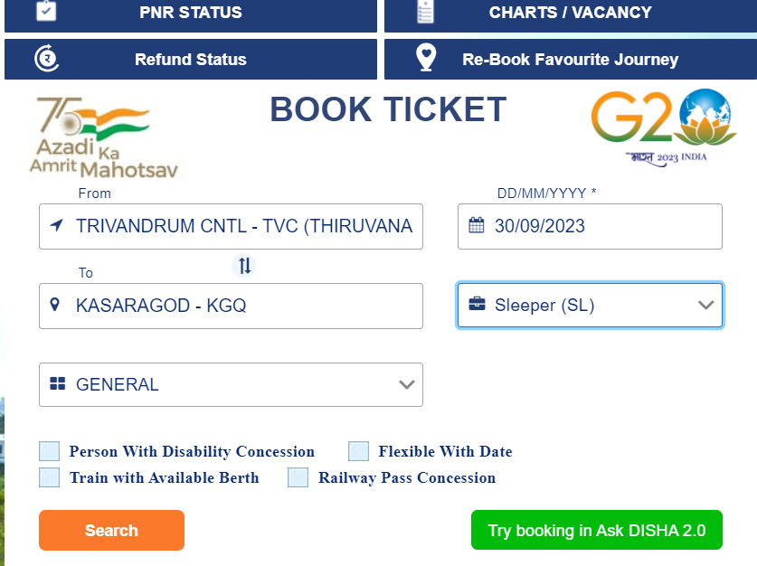

Figure 7

### Chapter 2.2.2- Select train.

1. The page displays the list of trains available for the selected route.
2. You can make modifications to your journey details and search again using modify search.
3. Select the train of your choice

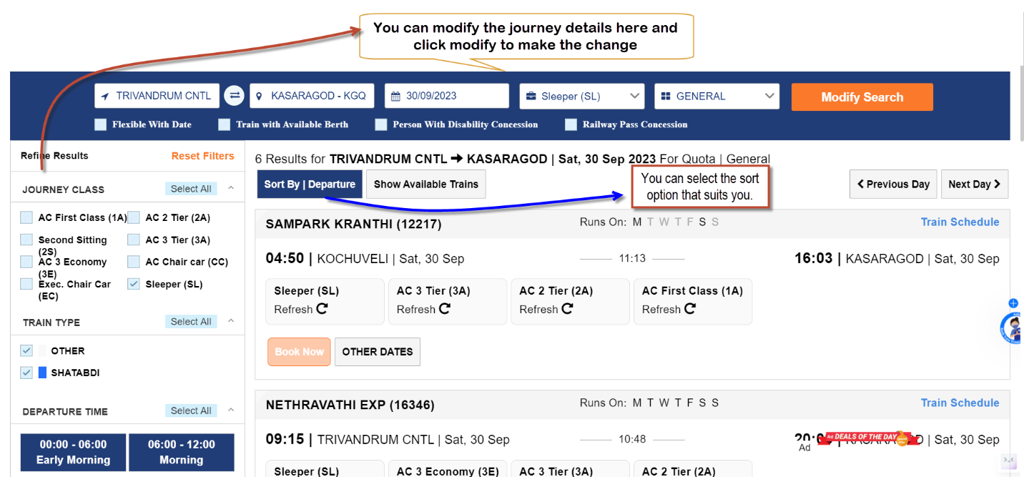

Figure 8

1. After deciding on the train, you can check the availability of seats in each class on that train for each day.

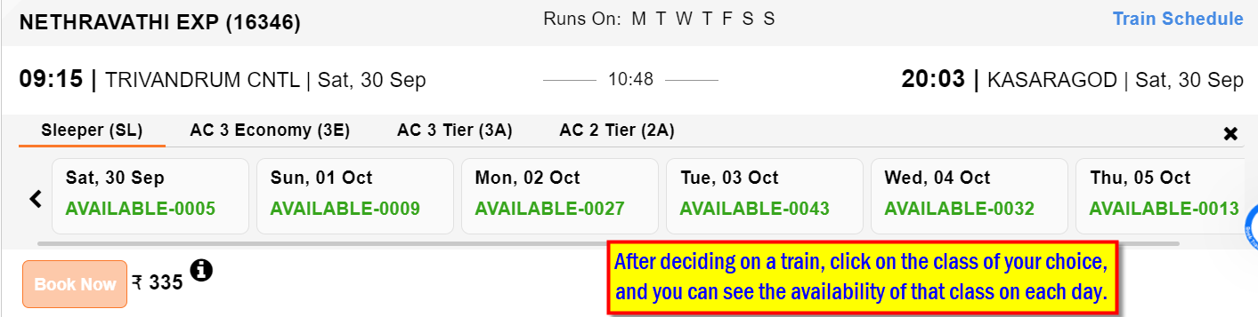

Figure 9

### Chapter 2.2.3- Select Seat.

1. After selecting the class and date of the journey, you can click on your choice.
2. To book an e-ticket for the selected train, click on the "Book Now" button.

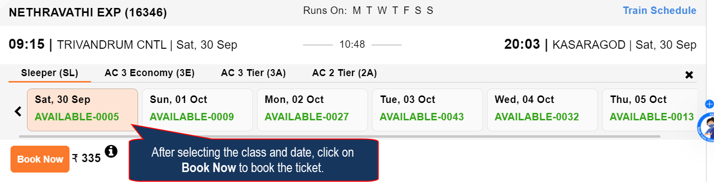

Figure 10

### Chapter 2.2.4- Enter Passenger details.

1. Passenger Reservation Page will appear; check whether the train name, station names, class, and journey date displayed on the page are the same as desired by you.
2. Enter the name of the passengers, age, gender, berth preference, etc. details for each passenger.

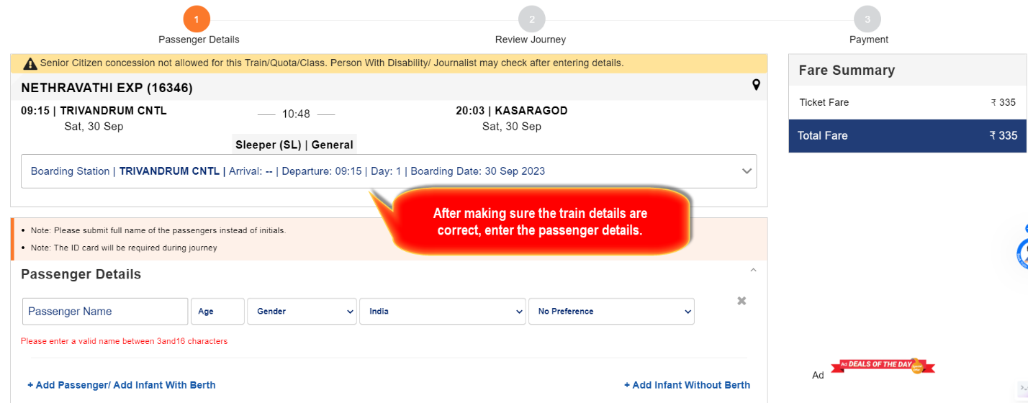

Figure 11

1. Enter your phone number in the contact details; it is mandatory.
2. In preferences, you can make your choices; it is optional.

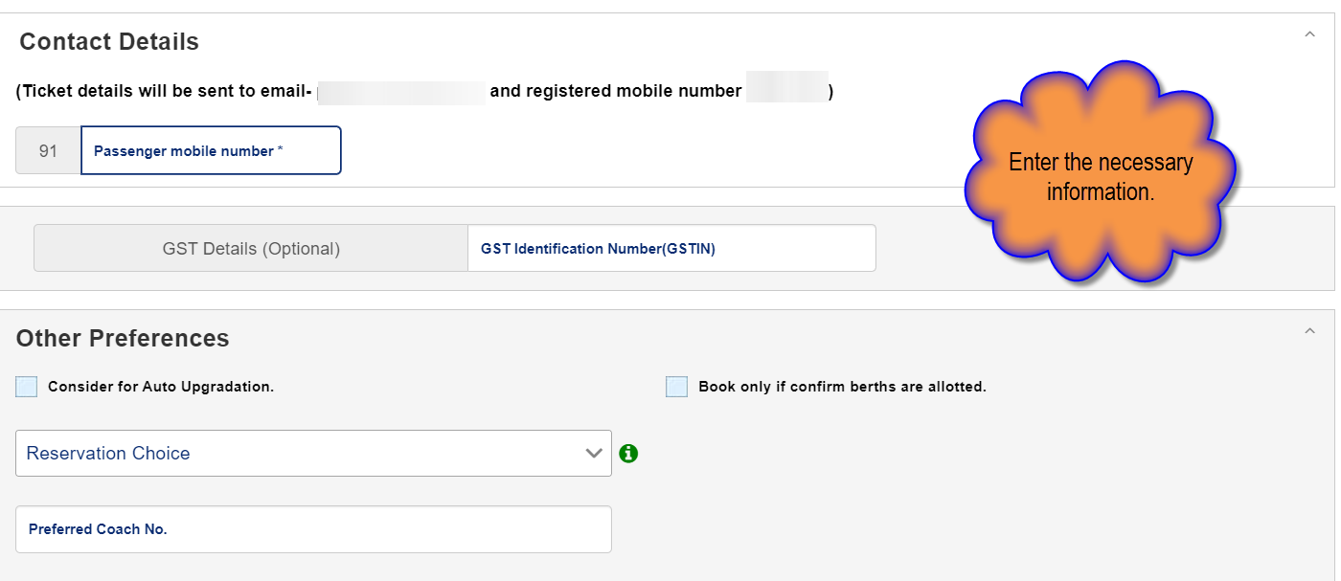

Figure 12

1. Travel insurance is optional.
2. Select the payment mode of your choice and click **Continue**.
3. If you want to make any changes in travel details you can click Back.

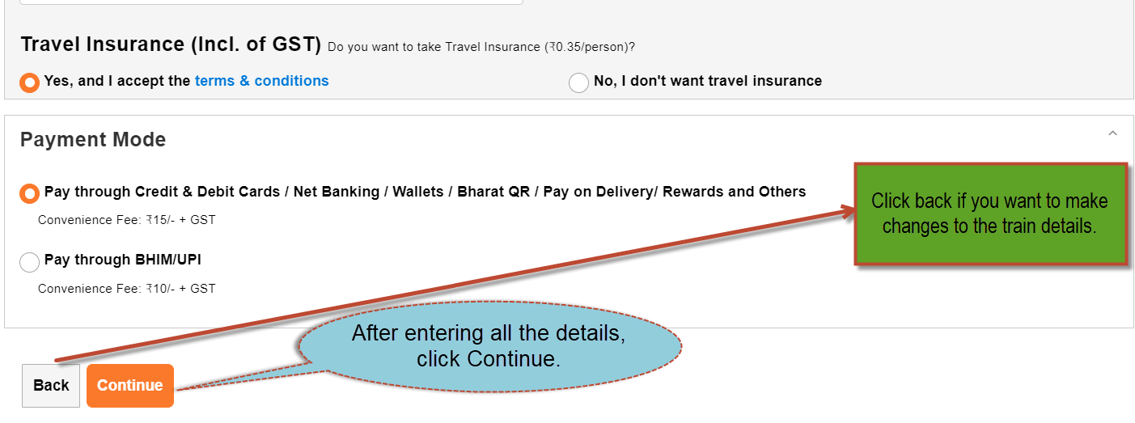

Figure 13

### Chapter 2.2.5-Check details.

1. All the information of the journey will be provided, including tarin details, passenger details, and fare of the journey
2. If the details are correct, you enter the captcha and click on **Continue** to make the payment; if the details are wrong, click on Back to make changes.

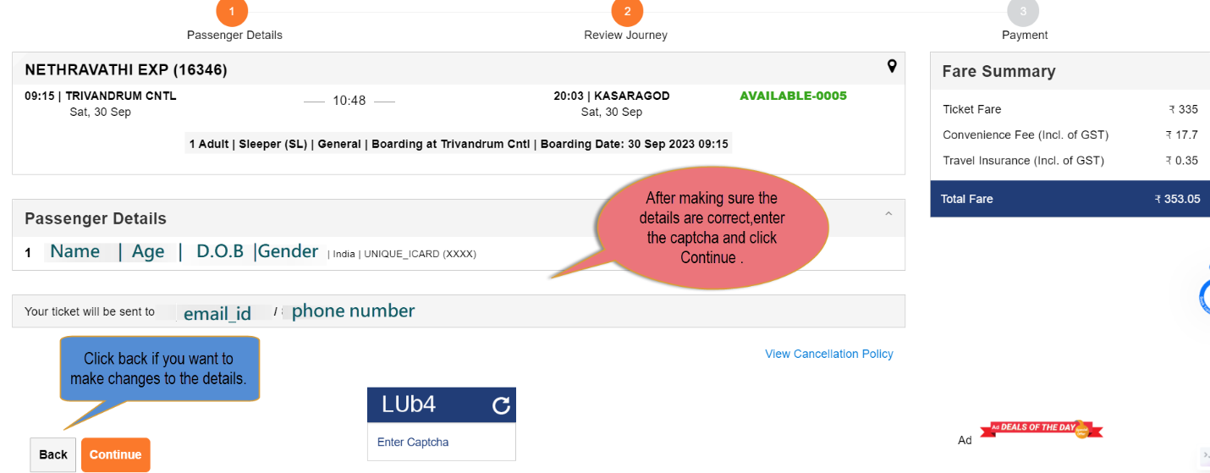

Figure 14

### Chapter 2.2.6- Payment.

1. Make sure the journy summary is correct if not click Bank to make changes.
2. Select the payment method of our choice and click on **Pay & Book.**
3. You will be taken to the payment gate. Make the payment there.

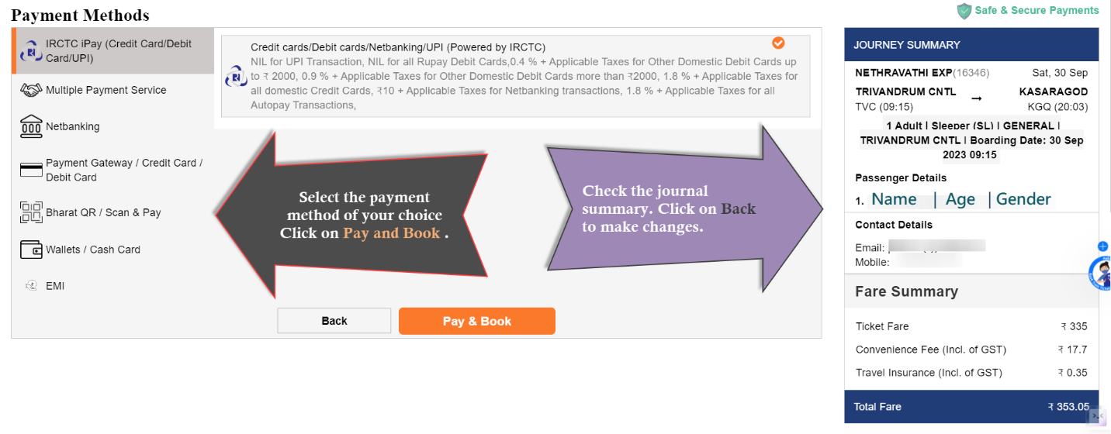

Figure 15

## Chapter 2.3 - BookaTatkalTicket

1. Tatkal tickets can only be booked one day prior to the journey.
2. OntheBook ticket page,provide your desired from-to station, date of journey.
3. Select a class of our choice or you can keep it as All Classes.
4. Select ticket type tatkal.



Figure 16

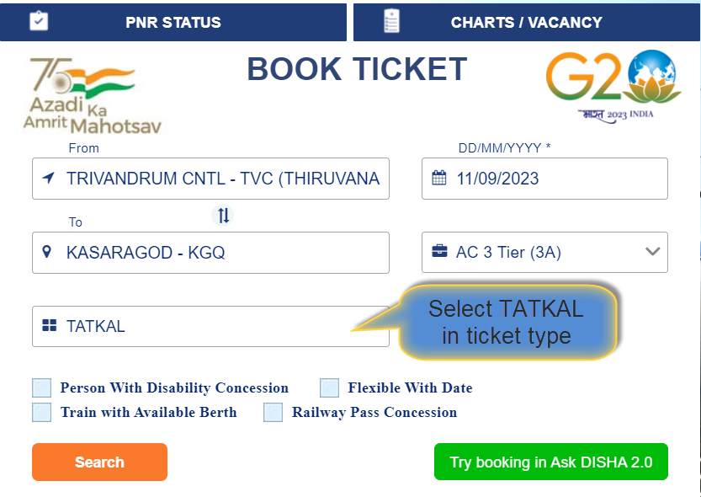

Figure 17

After clicking on Seach , it’s the same as E-Ticket steps.Click here to go to next step.